Group Members: Anis Ben Ammar, Mariem Mkassmi, Ines Bourguiba

**E-commerce project**

Build an e-commerce website where users can register/login and upload products to sell to other users.

**WireFrame**

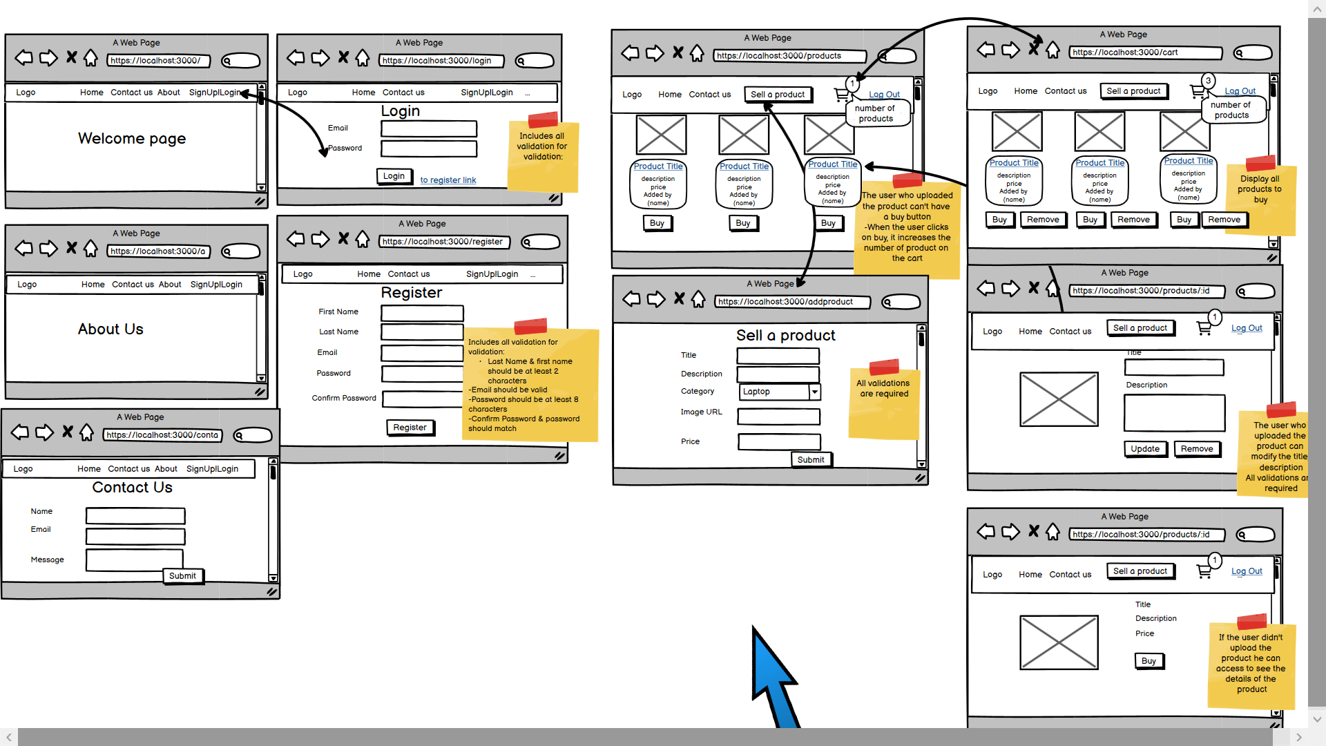

**Requirements :**

**1- User Registration:**

Users should be able to create an account with:

* First name (at least 2 characters)
* Last name (at least 2 characters)
* **Unique email** (not used email)
* Password, the user should confirm his password. (at least 8 characters)

Users should provide their email address for account verification and password recovery.

**2-User Authentication:**

Users should be able to log in to their account using their email and password.

The application should authenticate the user's credentials and grant access to the account.

Authentication is mandatory before any action (Protected routes).

**3-Creation of products: (add a product)**

Users should be able to create a new product.

Each product should have:

* Category of product (cosmetic, vehicle, laptop, phone, accessories, games)
* Product Name ( 5 characters)
* Description (length must be at least 5 characters) .
* Price
* Photo

Errors are displayed

**4-Display products:**

* Users should be able to view a list of all products (his products and others products) and who added the product.
* Users can do research per type of product.
* Users can access the details of each product by clicking on the product name of the product.
* Details displayed: the photo, the price, the production name and description

**5-Product Update:**

* Users who uploaded a product should have the ability to update his product.
* The user can’t modify a product or delete a product that wasn’t uploaded by him.
* Users can only buy a product or cancel when he is not the one who uploaded the product.

**6-Product Delete:**

There is an icon in the navbar that the user can click on and display the bought products and total price.



When the user clicks on buy => The product should be deleted